How to read and create 1-pagers for AP Human Geography
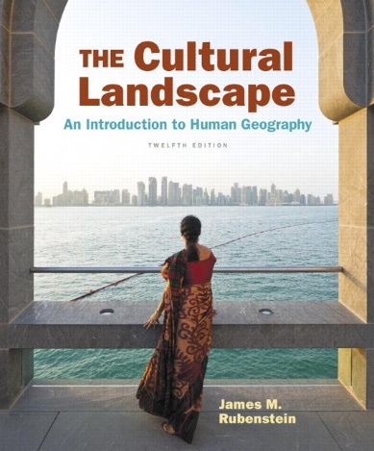
Use this outline to create your 1-Pager. You must make a 1-Pager for every key issue in AP Human Geography because:
- Each section is a summary of the assigned reading
- It connects all of the vocabulary and key concepts form your KBAT
- You can use it on your chapter test
- It’s another way to showcase your learning – especially if you do not do well on tests or worry about taking tests
SQ3R Reading Notes
SQ3R notes will help you to better understand and remember what you read in your textbook. Follow these steps:
- SURVEY – survey the entire chapter by scanning the titles, headings, pictures, and chapter summaries to get a general understanding of what the reading assignment
- QUESTION – As you survey, ask yourself questions about the information in various sections. Turn headings, etc. into questions.
- READ – Actively read for comprehension and to locate the answers to your questions. Include key concepts and important facts.
- RECITE – Transfer information to long term memory by answer the questions in your own words with a partner or independently
- REVIEW – Review main ideas and concepts and make connections between the reading and your KBAT; add to your notes and use highlighters and color to aid in your understanding.
Reading Homework: tale SQ3R readings notes for each Key Issue of the chapter. Include definitions and examples. Know the key terms from the chapter and be able to explain the main ideas (use your KBAT!).
AP HuG “One Pager” Chapter Review Rubric (30 points/project)

 |  | Points Possible | Points Earned
Title of Chapter and Key Issues clearly displayed |  | 2
Includes all bold vocabulary words |  | 10
Contains all sections with vocab words/concepts from each issue in the correct section. Make sure that you can answer the question of the key issue. |  | 8
At least two visual or graphic examples directly connected to an issue/vocab word |  | 4
At least one clearly labeled current event or real-world example that connects to an idea or vocab word |  | 2
Your biggest takeaway from the Key Issue. (“The most important thing I learned was…”) |  | 2
All space is filled. Writing is legible. Some color is present. |  | 2
Unit Title | Chapter Title
Key Issue Question

Vocabulary | Current Event or Real-World Example
Include all bolded vocabulary that helps you to answer the question… | Title, Author, Summary and Link to Key Issue Question
Visuals | Take-Away
Must link to vocabulary or key concept | (“The most important thing I learned was…”

