Cold War Map Activity
Use the maps in your text to complete the assignment.
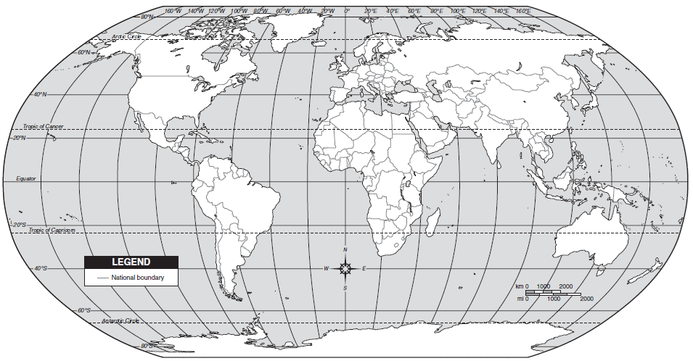
World Map: Locate the following countries and outline and shade them the appropriate color.
Superpowers: US (Dark Blue), Soviet Union (Red) – note that you will need to include some other nations in with the former USSR.
Countries of Conflict: China (Orange), Korea (Yellow), Cuba (Green), Vietnam (Purple)
Alliances: NATO members (Light Blue), Warsaw Pact members (Pink)
Cold War Hot Spots

Draw the division between East and West Germany
Color the West BLUE and the East RED
Locate and Label Berlin
Draw the division between North and South Korea
Color North RED and South BLUE
Locate and Label the Pyongyang and Seoul
Draw the division between North and South Vietnam
Color North RED and South BLUE
Locate and Label Laos and Cambodia
Color them any color you choose
Locate and Label Hanoi and Saigon

